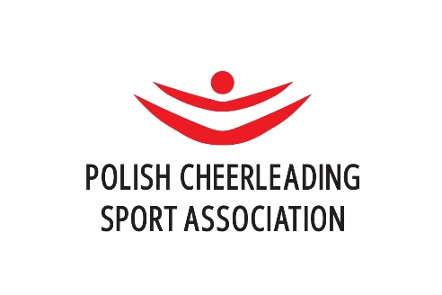

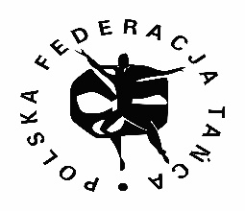

International Łochów Cup
02.12.2023 Łochów, Poland

Date & place
02.12.2023
Hala Sportowo-Widowiskowa im. M Dzięcioła w Łochowie
Wyspiańskiego 20, 07-130 Łochów, Poland /85 km from Warsaw Chopin Airport/

ECU ECL divisions:
- Cheerleading - Team Coed Premier, Senior
- Cheerleading - Team All Girl Premier, Senior
- Performance Cheer - Team Cheer Freestyle Pom, Senior
- Doubles Cheer Freestyle Pom, Senior
- Doubles Cheer Hip Hop, Senior
- Cheerleading - Team Coed Elite, Junior
- Cheerleading - Team All Girl Elite, Junior
- Performance Cheer - Team Cheer Freestyle Pom, Junior
- Doubles Cheer Freestyle Pom, Junior
- Doubles Cheer Hip Hop, Junior

Additional divisions:
Cheerleading :
- All Girl/Coed teams (Tiny L1, Minis L2&L3, Youth L3, Junior L4, Senior L5)
- Group stunts (Tiny L1, Minis L2&L3, Youth L3, Junior L4, Senior L5)
- Partner Stunt (Junior L4 and Senior L5)
Performance Cheer teams and doubles
- Pom (Tiny, Minis and Youth)
- Cheer Hip Hop (Tiny, Minis, Youth, Junior and Senior)
- Cheer Jazz (Tiny, Minis, Youth, Junior and Senior)
Pom Dance teams
- Elite (Tiny, Minis, Youth, Junior, Senior and Masters)
- Premier (Tiny, Minis, Youth, Junior, Senior and Masters)

Age categories:

 | Od 2023 | Roczniki
TINY | till 9 y.o. | 2014, 2015, 2016….
MINIS | 8 – 13 y.o. | 2010 – 2015
YOUTH | 12 – 15 y.o. | 2008-2011
JUNIOR | 14 – 19 y.o. | 2004-2009
SENIOR | 16 + | 2007 and before
MASTERS | 30 + | 1993 and before

Rules:
We follow ECU Rules 2023 in cheer and performance cheer divisions and PCSA rules in Pom Dance divisions.

Number of athletes:

 | Number of Athletes | Substitutes | Coaches/Entourage
Cheer All Girl/Coed | 16 - 24 | Max 5 | Max 5
Group Stunt All Girl/Coed | 4 - 5 | Max 2 | Max 2
Partner Stunt Coed | 2 | Max 2 | Max 2
Cheer Solo | 1 | - | Max 1

 | Number of Athletes | Substitutes | Coaches/Entourage
Team Performance Cheer and Pom Dance | 6 – 24 | Max 5 | Max 5
Doubles Performance Cheer | 2 | Max 2 | Max 2

Judges:
The competition will be judged by International Judges /ICU/ and Polish Judges /PCSA/.

Dimentions of the floor/mat:
Cheer division – cheer mat 14m x 14m
Performance Cheer & Pom dance – ballet floor 14m x 14m

Registration and participation fee:
Early Registration 01.10.2023 till 31.10.2023 - 20 euro/per person
Every additional division + 10 euro/per person

Late registration 1 - 15.11.2023 - 30 euro/per person
Every additional division + 15 euro/per person

Bank account:
Klub Sportowy Cheerleaders Iskra
Ul. Wyspiańskiego 20
07-130 Łochów
SWIFT: BIGBPLPW
IBAN PL 87 1160 2202 0000 0005 0514 5944

Transfer title: “ ECU ECL, team name, division , number of athletes”

Let us know if you need invoice

More info will be posted on:
https://www.pzsc.pl/eng/71,International_Lochow_Cup_-_ECU_ECL_2023.html

Contact person - Anna Polatowska-Zegar
a.polatowska-zegar@pzsc.pl"

We invite all international friends to join us and celebrate Iskra Cheerleading Club anniversary – 25 years

